High Level Design

Main functions of DirectX that are likely to be used

To set up directX to draw any shape, it must use the following functions and objects must be called, created (in order):

Direct3DCreate9() – The first step in writing a Direct3D program is to create a Direct3D object from the IDirect3D9 interface.

CheckDeviceType() - When the Direct3D application first runs, it should check for the availability of the display mode the application needs. If the destination system cannot handle the required display mode, then the user must be informed of this fact. To check whether a particular display mode is available, the Direct3D object’s CheckDeviceType() method needs to be called.

GetAdapterDisplayMode() - If the Direct3D application is to run in a window, the application must set to the desktop’s current pixel format and screen resolution. To check the desktop’s current pixel format and screen resolution the Direct3D object’s GetAdapterDisplayMode() method needs to be called.

At present, my application runs in full screen mode. Hence the Direct3D object’s CheckDeviceType() method needs to be called. Eventually I would like to display the program in a window. Hence the Direct3D Object’s GetAdapterDisplayMode() method would need to be called instead of CheckDeviceType().

After the Direct3D object is created, the Direct3Ddevice must be created. The direct3D device is an object of the IDirect3Ddevice9 interface.

Clear() - At the start of every rendered frame, the Direct3Ddevice’s Clear() method needs to be called. This method simply clears the surface of the previous rendering. The background surface can be cleared with any colour, for my initial project goal, only a black background is required

Before any graphics primitives can be rendered, a call to the Direct3D transformations is required. There are 3 types of transformations to set up:

- World Transformation – This transformation determines the location and position of the graphical objects in the 3D world where you apply rotations, translations, scaling. There are a list of D3DXMatrix transformation functions that will be used by my project, these include:
- D3DXMatrixTranslation() – Applies a translation to a matrix
- D3DXMatrixRotationX() – Applies rotation around the X axis
- D3DXMatrixRotationY() – Applies rotation around the Y axis
- D3DXMatrixRotationZ() – Applies rotation around the Z axis
- D3DXMatrixScaling() – Applies scaling to a matrix

Once the required Direct3D transformation has been calculated, it is applied by making a call to the Direct3Ddevices’s SetTransform() method.

- View Transformation –Vectors for Eye, LookAt and Up must be initially defined. A matrix must then be set up for the transformation by calling the Direct3D utility function D3DXMatrixLookAtLH().To give the transformation to Direct3D, the SetTransform() method must be called.

- Projection Transformation - Similar operation to both view and world transformation.

With the viewpoint setup correctly, the program must create the required primitives to be rendered. The shell shape will eventually be made up entirely of triangle primitives. The vertices of these primitives are calculated using a formula related to the shell spiral. With the vertices calculated and number of vertices to be displayed defined, the next step in DirectX is to allocate storage for these vertices.

CreateVertexBuffer() - The CreateVertexBuffer() method is available for the Direct3Ddevice object, that creates a vertex buffer object for the vertex data.

Lock(), Unlock() - To load the vertex buffer with data, the buffer must be locked, this is done by calling the vertex buffer object’s lock() method. Data is loaded and then the vertex buffer’s unlock() method is called to resume rendering.

SetStreamSource(), SetFVF() - To tell direct3D where the vertices are stored, the program calls the Direct3D device object’s SetStreamSource() method. The next step is to tell direct3D how to shade the graphic primitives. This is done by calling the Direct3Ddevice’s SetFVF() method.

BeginScence() - Before drawing the primitives, a call to Direct3Ddevice object’s BeginScene() method is required.

DrawPrimitive() - Finally to draw the primitive(s), a call to the Direct3Ddevice object’s DrawPrimitive() method is required.

EndScene() - After the DrawPrimitive() method has been called, Direct3Ddevice object’s EndScene() must be called.

Applications must call the BeginScene() method before performing any rendering and must call EndScene() when rendering is complete

Present() - To overwrite the previous screens surface with the new rendering data (background, primitives), a call to the Direct3Ddevice object’s Present() method is required.

Release() - Before the application terminates, memory for the Direct3D and Direct3Ddevice objects need to be de-allocated. To de-allocate the memory call their respective release() methods.

Mathematical Model

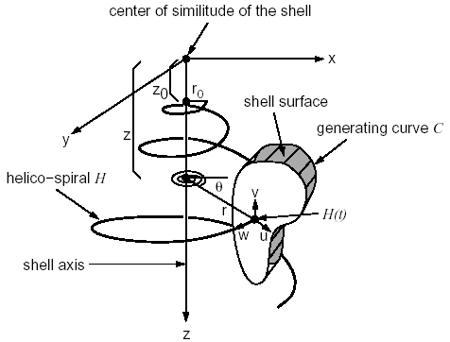

Choose initial values for the following constants:

θ₀ – The angle from which the spiral begins
Δθ - Steps (step size) taken to calculate points (vertices) on the spiral
λ –A constant
R₀ – the initial length of the spiral radius
Z₀ – the initial depth of the spiral

r
y

θ
x

Equations:
θ_{(i+1)} = θ_{i} + Δθ
r_{(i+1)} = r_{i} x λ
x_{(i+1)} = r_{(i+1)} cosθ_{(i+1)}
y_{(i+1)} = r_{(i+1)} sinθ_{(i+1)}
z_{(i+1)} = z_{i} x λ

Sweep technique to Create the Outer Surface of the Shell

Initially choose an aperture shape. For simplicities sake, a diamond shape will suffice.
z

V0

V3
V1
x
y
x

V2

The diamond shape has only x and y coordinates, z = 0.

Store the vertex coordinates of the diamond shape. In the example above there are 4 3-D coordinates:

V0 = {0,1,0}
V1 = {1,0,0}
V2 = {0,-1,0}
V3 = {-1,0,0}

Straight Line

In order to get to grips with the technique, a straight-line sweep is demonstrated.

Point 0
Point 1
Point 2
Point 3
Point 4
x
z

Translate the centre of the diamond to line up with each of the points along the line. For each point (0 to 4) calculate 4 new vertices which correspond to the translated diamond points. It is then possible to connect the new vertex points with triangles. In the case of the diamond sweep there will be 4 surfaces, hence 4 sets of triangle strips will be used to create the outer surface. The number of required triangle strips is equal to the number of sides the sweeping shape has.
y
z
z

x
x

The triangles are connected length ways for each of the four surfaces. To limit the number of vertices the triangles are implemented with triangle strip primitives.
Curve

Once a straight path has been implemented using the sweep technique, it is then easy to progress onto a curved path.

y
x
Point 0
Point 1
Point 2
Point 3
Point 4
Point 5

To calculate the angle at which the diamond shape should be placed at along the curved path is elementary:

Lets say at point 0, n equals 0, at point 1, n equals 1 etc. The value of n is multiplied by Δθ (the angular step size) value to calculate the angle at which the shape template should be orientated.

For example, if n = 3 and Δθ (angular step size) = 10 degrees, assuming the aperture shape is as shown below:
Vertex0
Centre of Diamond

Vertex1
Vertex2

Vertex1

- Take note of the diamonds coordinates (it’s vertices and centre) centred on the world coordinate system

x
y
z
y

- Rotate all the diamonds vertices about the z-axis by (n * Δθ)

x
y
z
y

- Translate the updated vertices back to point n

y
x

- The above 3 steps are then carried out on point 0 to point n.

y
x

y

After all the sweep points have been calculated, it’s just a matter of creating the four surfaces using triangle strips as shown in the straight line path example.

Spiral

The spiral shape is just a succession of curves; hence the transistion from calculating the points along a 2D curve to calculating points along a 2D spiral is trivial. Exactly the same method as described for the curve need be followed.

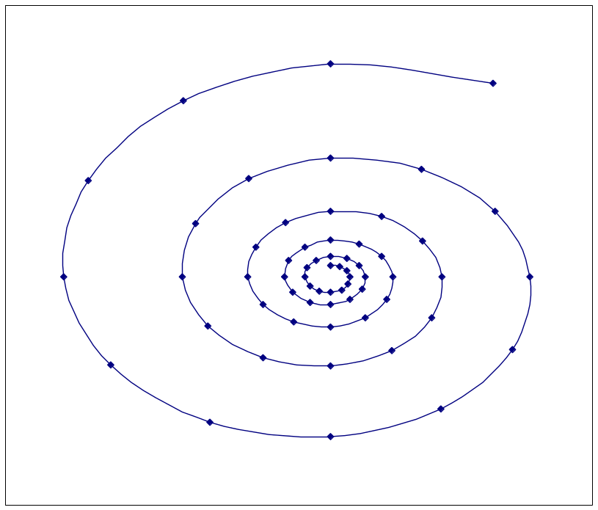

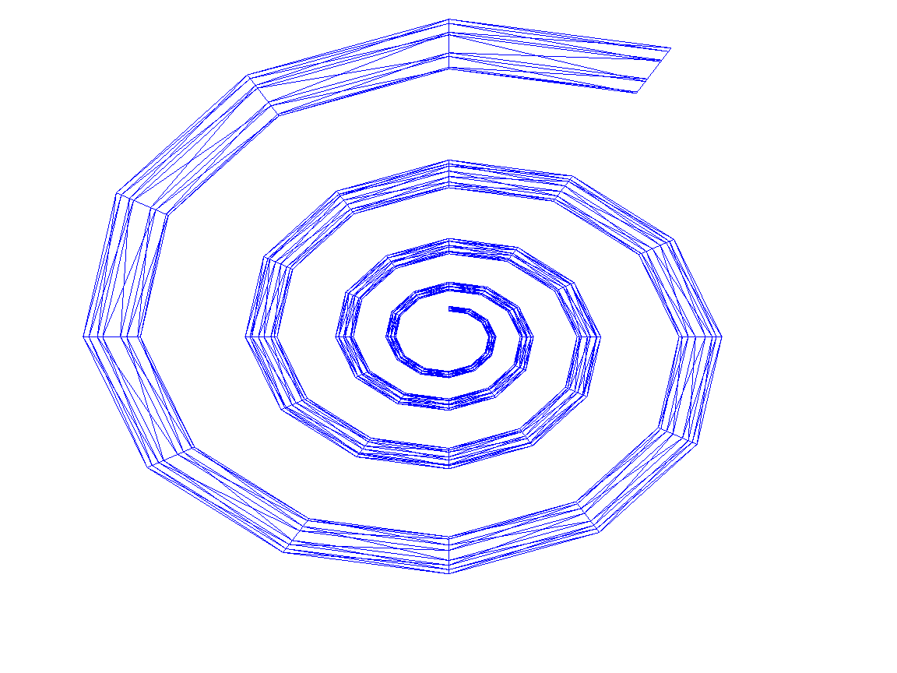
The aperture shape of many shells is circular. To accurately define a circle a large number of vertices are required. An octagon type shape gives a very basic representation of a circle without having too many vertices.
y

V0

V7

V6

V5

0.6
1.0
1.0
0.3

V1

V2

V3

V4
x

There are 8, 3-D coordinates that define this circle:

V0 = {0.0,1.0,0.0}
V1 = {0.6,1.0,0.0}
V2 = {1.0,0.0,0.0}
V3 = {0.6,-0.6,0.0}
V4 = {0.0,-1.0,0.0}
V5 = {-0.6,-0.6,0.0}
V6 = {-1.0,0.0,0.0}
V7 = {-0.6,0.6,0.0}

Exactly the same methodology is applied to the circular shape, which has been the case for diamond shape. However the shell surface will be made up of 8 surfaces as opposed to 4.

